Changes in collab:
ADD FOLDERS:
- monodepth_logs
- split>mind3d
1. Add mind3d_dataset.py found in visual studio code:
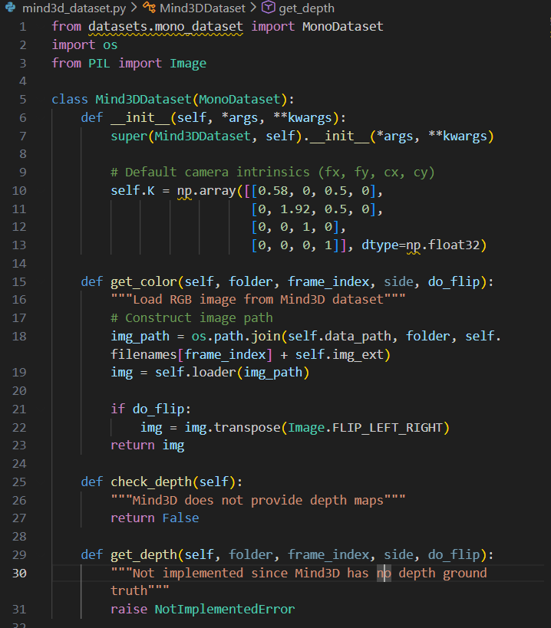
CODE:
from datasets.mono_dataset import MonoDataset
import os
import numpy as np
import random
import torch
from PIL import Image
from torchvision import transforms

class Mind3DDataset(MonoDataset):
def __init__(self, *args, **kwargs):
super(Mind3DDataset, self).__init__(*args, **kwargs)

# Camera intrinsics normalized (fx, fy, cx, cy)
self.K = np.array([[0.58, 0, 0.5],
[0, 1.92, 0.5],
[0, 0, 1]], dtype=np.float32)

def check_depth(self):
return False # Mind3D is RGB-only for now

def get_color(self, folder, frame_name, side, do_flip):
img_path = os.path.join(self.data_path, folder, f"{frame_name}{self.img_ext}")
img = self.loader(img_path)
if do_flip:
img = img.transpose(Image.FLIP_LEFT_RIGHT)
return img

def get_depth(self, folder, frame_name, side, do_flip):
return None # No depth for Mind3D yet

def get_neighbor(self, index, offset):
"""Get timestamp filename for temporal neighbor"""
neighbor_idx = index + offset
neighbor_idx = max(0, min(len(self.filenames) - 1, neighbor_idx)) # clamp to valid range
return self.filenames[neighbor_idx].split()[1]

def __getitem__(self, index):
inputs = {}

do_color_aug = self.is_train and random.random() > 0.5
do_flip = self.is_train and random.random() > 0.5

line = self.filenames[index].split()
folder = line[0]
side = None

# Load all frames in frame_idxs (e.g., [0, -1, 1])
for i in self.frame_idxs:
neighbor_name = self.get_neighbor(index, i)
inputs[("color", i, -1)] = self.get_color(folder, neighbor_name, side, do_flip)

# Intrinsics for each scale
for scale in range(self.num_scales):
K = self.K.copy()
K[0, :] *= self.width / (2 ** scale)
K[1, :] *= self.height / (2 ** scale)
inv_K = np.linalg.inv(K)
inputs[("K", scale)] = torch.from_numpy(K)
inputs[("inv_K", scale)] = torch.from_numpy(inv_K)

# Color augmentation
color_aug = transforms.ColorJitter(
brightness=self.brightness,
contrast=self.contrast,
saturation=self.saturation,
hue=self.hue
) if do_color_aug else (lambda x: x)

# Preprocess will create color/color_aug for scales 0..3
self.preprocess(inputs, color_aug)

# Remove original resolution keys AFTER preprocess
for i in self.frame_idxs:
del inputs[("color", i, -1)]
del inputs[("color_aug", i, -1)]

return inputs

2. trainer.py: update dataset dict with Mind3DDataset in trainer.py lin 113
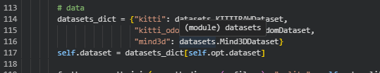
3. options.py: update options.py in line 34 add "mind3d" in choices
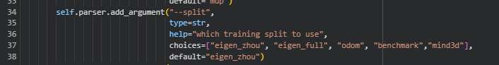
4. options.py: add mind3d in the dataset line 48
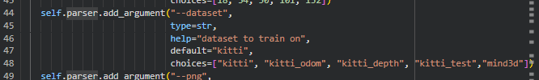
5. networks>resnet_encoder.py line 54
From:
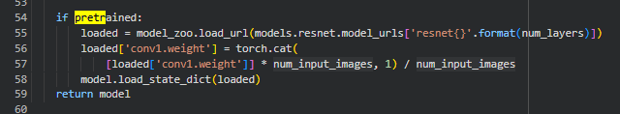
Change to:
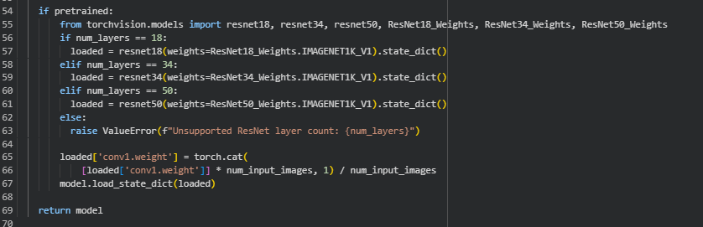
if pretrained:
from torchvision.models import resnet18, resnet34, resnet50, ResNet18_Weights, ResNet34_Weights, ResNet50_Weights
if num_layers == 18:
loaded = resnet18(weights=ResNet18_Weights.IMAGENET1K_V1).state_dict()
elif num_layers == 34:
loaded = resnet34(weights=ResNet34_Weights.IMAGENET1K_V1).state_dict()
elif num_layers == 50:
loaded = resnet50(weights=ResNet50_Weights.IMAGENET1K_V1).state_dict()
else:
raise ValueError(f"Unsupported ResNet layer count: {num_layers}")

loaded['conv1.weight'] = torch.cat(
[loaded['conv1.weight']] * num_input_images, 1) / num_input_images
model.load_state_dict(loaded)

return model
6. “datasets” folder> “__init__.py” add Mind3DDataset
from .mind3d_dataset import Mind3DDataset
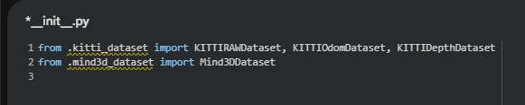
7. datasets> mono_dataset.py (line 57) > Change self.interp from antialias to Resampling.LANCZOS
From:
Change to:
self.interp = Image.Resampling.LANCZOS
8. layers.py: line 171, under Project3d class, line 181 change the multiplication code to this format: P = P = torch.matmul(K, T[:, :3, :])
From:
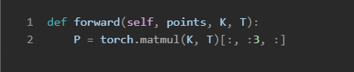
Change to:
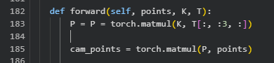
9. trainer.py: line 326 and line 329, do this change: inputs = next(self.val_iter)
from:
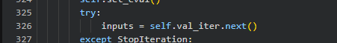
Change to:
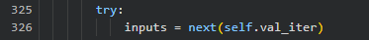

10. trainer.py (line 194): put self.model_lr_scheduler.step() at the end of the function rather than at the first part
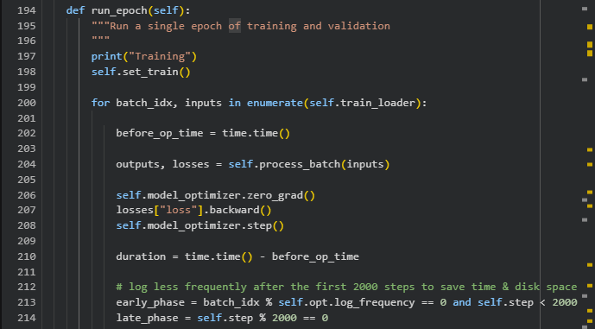
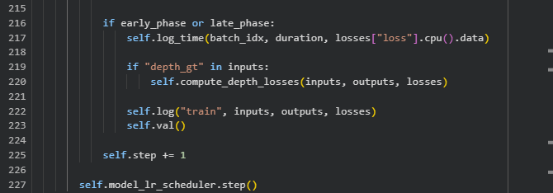
11. Update resnet encoder to new syntax: weights= keyword and Weights enums
# Copyright Niantic 2019. Patent Pending. All rights reserved.
#
# This software is licensed under the terms of the Monodepth2 licence
# which allows for non-commercial use only, the full terms of which are made
# available in the LICENSE file.

from __future__ import absolute_import, division, print_function

import numpy as np

import torch
import torch.nn as nn
import torchvision.models as models
# REMOVED: torch.utils.model_zoo (deprecated and unused)

class ResNetMultiImageInput(models.ResNet):
"""Constructs a resnet model with varying number of input images.
Adapted from https://github.com/pytorch/vision/blob/master/torchvision/models/resnet.py
"""
def __init__(self, block, layers, num_classes=1000, num_input_images=1):
super(ResNetMultiImageInput, self).__init__(block, layers)
self.inplanes = 64
self.conv1 = nn.Conv2d(
num_input_images * 3, 64, kernel_size=7, stride=2, padding=3, bias=False)
self.bn1 = nn.BatchNorm2d(64)
self.relu = nn.ReLU(inplace=True)
self.maxpool = nn.MaxPool2d(kernel_size=3, stride=2, padding=1)
self.layer1 = self._make_layer(block, 64, layers[0])
self.layer2 = self._make_layer(block, 128, layers[1], stride=2)
self.layer3 = self._make_layer(block, 256, layers[2], stride=2)
self.layer4 = self._make_layer(block, 512, layers[3], stride=2)

for m in self.modules():
if isinstance(m, nn.Conv2d):
nn.init.kaiming_normal_(m.weight, mode='fan_out', nonlinearity='relu')
elif isinstance(m, nn.BatchNorm2d):
nn.init.constant_(m.weight, 1)
nn.init.constant_(m.bias, 0)

def resnet_multiimage_input(num_layers, pretrained=False, num_input_images=1):
"""Constructs a ResNet model with multi-image input.
Args:
num_layers (int): Number of resnet layers. Supported: 18, 34, 50
pretrained (bool): If True, returns a model pre-trained on ImageNet
num_input_images (int): Number of frames stacked as input
"""
assert num_layers in [18, 34, 50], "Supported ResNet layers: 18, 34, 50"

blocks = {18: [2, 2, 2, 2],
34: [3, 4, 6, 3],
50: [3, 4, 6, 3]}[num_layers]
block_type = {18: models.resnet.BasicBlock,
34: models.resnet.BasicBlock,
50: models.resnet.Bottleneck}[num_layers]
model = ResNetMultiImageInput(block_type, blocks, num_input_images=num_input_images)

if pretrained:
from torchvision.models import (
resnet18, resnet34, resnet50,
ResNet18_Weights, ResNet34_Weights, ResNet50_Weights
)
if num_layers == 18:
loaded = resnet18(weights=ResNet18_Weights.IMAGENET1K_V1).state_dict()
elif num_layers == 34:
loaded = resnet34(weights=ResNet34_Weights.IMAGENET1K_V1).state_dict()
elif num_layers == 50:
loaded = resnet50(weights=ResNet50_Weights.IMAGENET1K_V2).state_dict() # V2 is common for resnet50
else:
raise ValueError(f"Unsupported ResNet layer count: {num_layers}")

# Adapt first conv to accept N images by repeating weights across the channel dimension
loaded['conv1.weight'] = torch.cat(
[loaded['conv1.weight']] * num_input_images, dim=1
) / num_input_images

model.load_state_dict(loaded, strict=False)

return model

class ResnetEncoder(nn.Module):
"""Pytorch module for a resnet encoder"""
def __init__(self, num_layers, pretrained, num_input_images=1):
super(ResnetEncoder, self).__init__()

self.num_ch_enc = np.array([64, 64, 128, 256, 512])

# Map layers to constructors
resnets = {
18: models.resnet18,
34: models.resnet34,
50: models.resnet50,
101: models.resnet101,
152: models.resnet152
}

if num_layers not in resnets:
raise ValueError(f"{num_layers} is not a valid number of resnet layers")

if num_input_images > 1:
# Use the multi-image variant
self.encoder = resnet_multiimage_input(num_layers, pretrained, num_input_images)
else:
# Use TorchVision weights enums instead of deprecated 'pretrained' positional arg
if pretrained:
from torchvision.models import (
ResNet18_Weights, ResNet34_Weights,
ResNet50_Weights, ResNet101_Weights, ResNet152_Weights
)
weights_enum = {
18: ResNet18_Weights.IMAGENET1K_V1,
34: ResNet34_Weights.IMAGENET1K_V1,
50: ResNet50_Weights.IMAGENET1K_V2,
101: ResNet101_Weights.IMAGENET1K_V2,
152: ResNet152_Weights.IMAGENET1K_V2
}[num_layers]
# FIXED: Instantiate the model with weights
self.encoder = resnets[num_layers](weights=weights_enum)
else:
# FIXED: Instantiate the model without weights
self.encoder = resnets[num_layers]()

# Channel multipliers for Bottleneck-based networks
if num_layers > 34:
self.num_ch_enc[1:] *= 4

def forward(self, input_image):
self.features = []
# Monodepth2's scalar normalization (kept as-is)
x = (input_image - 0.45) / 0.225
x = self.encoder.conv1(x)
x = self.encoder.bn1(x)
self.features.append(self.encoder.relu(x))
self.features.append(self.encoder.layer1(self.encoder.maxpool(self.features[-1])))
self.features.append(self.encoder.layer2(self.features[-1]))
self.features.append(self.encoder.layer3(self.features[-1]))
self.features.append(self.encoder.layer4(self.features[-1]))
return self.features
12. trainer.py (line 386) > change the code as needed
From:
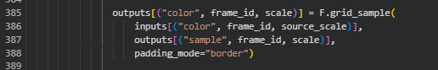
Change to:
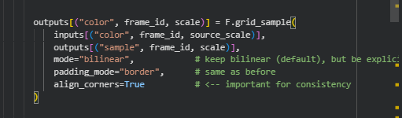

outputs[("color", frame_id, scale)] = F.grid_sample(
inputs[("color", frame_id, source_scale)],
outputs[("sample", frame_id, scale)],
mode="bilinear", # keep bilinear (default), but be explicit
padding_mode="border", # same as before
align_corners=True # <-- important for consistency
)

